‘Holiday? No. We’re going to A&E.’
(Daily Mail 12.1.17)

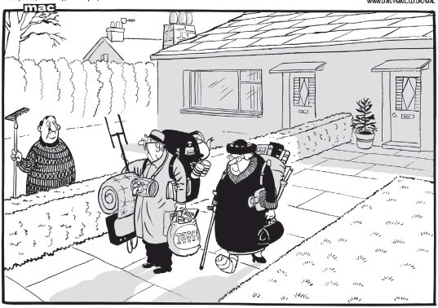
I saw this cartoon yesterday and it made me smile. It also made me think. What can we do to help improve this situation for people needing physio for whom the waiting lists are just too long?

So here it is our quest to help you ‘beat the blues and skip the queues’.

Physiotherapy sessions available every week for £32 (normally £42)

The details:

’Magnificent Monday’ - will be at our Salisbury clinic with sessions available between 1330 and 1530 every Monday, and

‘Fabulous Friday’ - will be at our David Lloyd Westbury, Bristol clinic with sessions available between 0930 and 1130 every Friday.

The small print:

* we guarantee to offer you an appointment within a week or less,
- you can have up to 10 sessions at this discounted rate giving a saving of up to £100,
- appointments must be within these times to benefit from the discounted rate or normal rates will apply,
- discounts cannot be used in conjunction with other offers/deal
- fees must be pay-as-you-go. (Cash or cheque only in Salisbury, cheque, card or cash in Bristol no Private Medical Insurance)

To book your appointment and get your aches and pains looked at quickly simply text or call 07984203698 or email enquiries@thephysioplace.com.

